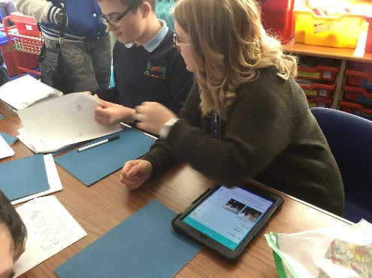
Kingswode Hoe School
Assessment and Marking Policy
At Kingswode Hoe School, we firmly believe that all pupils have the potential to grow and make exceptional progress from their starting points.
Assessment, clearly linked to the appropriate curriculum, has to be ‘right’ for our pupils and meet their needs. Pupils at Kingswode Hoe School are eager to learn and improve. They make progress as a whole person, both academically and socially, towards six clearly defined outcomes: resilience and independence; identity and self-expression; health, lifestyle and wellbeing; community and wider world; accreditation; employability. Strong assessment supports this by making sure pupils know how to improve and are well supported to develop skills, independence and understanding.
We have focused on our Ofsted targets from September 2014 to develop our approach to assessment and marking.
It is important to us that:
- pupils always know their next steps for learning when key pieces of work are marked

- pupils’ thinking is consistently extended so that they deepen their knowledge and understanding and develop new skills quickly

- subject leaders fully implement the new arrangements for assessment in their subjects and consistently check that teachers are using this information to extend pupils’ learning within their subjects.

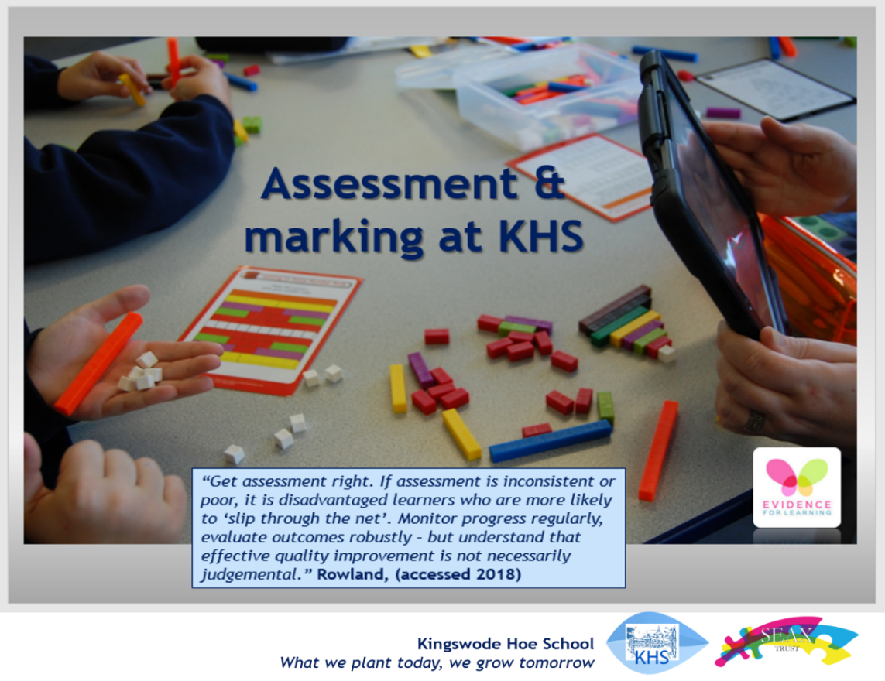

Marking and feedback
Our marking policy requires staff to give quality and accessible feedback to pupils. This may look different according to the needs of the pupil or group and can be verbal or written feedback. Pupils are given time and support to respond to any targets set and most importantly, know what to do to improve. Staff aim to give specific positive feedback for pupils, so they know what they have done well and on setting clear targets to enable them to take manageable next steps of progress. Staff have a simple scale to indicate how independent pupils have been and their depth of learning in the particular skill or objective they are aiming for.
To achieve our aim, you should see evidence of:
- Key written marked work using the agreed marking approach where pupils are able to access- regular verbal feedback is used to ensure assessment and feedback are accessible to all

- Pupils given opportunities to act on their individual targets set

A range of resources and assessment tools are used to indicate level of progress and set next steps. For example:

- Formal summative tests
- Mental/oral activities
- Entry level coloured A4 grid sheets

- Evidence collected using Evidence for Learning which allows teachers to back up each judgement made against their progress, independence and levels of effort and engagement

- Progress made monitored using the assessment visual for each pupil
- Targets set and monitored against the curriculum and the individual’s EHCP

Since the removal of levels in 2014, we have evaluated our assessment system and developed an approach that most suits our cohort of pupils and curriculum. Curriculum leaders have written their own frameworks to assess pupil progress and outcomes which link directly to the National Curriculum. As a special school, frameworks cover learning ‘I can’ statements from early learning goals through to pathways in Key Stage 4 to enable us to assess pupils from their own individual starting points rather than purely age-related expectations. We have also created a framework of social skills to ensure we track and monitor progress towards important social targets. At Kingswode Hoe School, we believe in growing these skills and abilities in pupils as well as maximising their academic potential.
Outstanding assessment involves pupils and ensures they know how to improve. Using iPads, staff are trained to capture, assess and document achievements and progress using the app ‘Evidence for Learning’ http://www.evidenceforlearning.net/. This is also a parental engagement tool. Staff add comments and, where appropriate, next step targets to photographic and video evidence and link to a subject and/or or social curriculum framework. Evidence can also be ‘tagged’ for a particular area of the curriculum or whole school priority.

We assess the pupil using the following descriptors in mark books for some subject areas:
Learning and progress is measured in three ‘levels’:
Secure
Developing
Emerging

Independence
Independent
Prompted
Modelled
Fully supported
We also measure how independent pupils have been, as whilst they may not have made significant progress according to the depth of learning, they may have become much more independent in a particular area or skill, often a target on their EHCP and so important to equip our pupils for the future. We place a high value on increasing independence for our pupils, many of whom have become very dependent on 1:1 support prior to joining our school.
Effort
Exceeding
Secure
Requires improvement
Poor
We report to parents and carers about the level of effort pupils have applied in different subjects and areas across the curriculum.

Our assessment system matches our curriculum and enables us to capture and report on a wide range of evidence of learning and pupil progress. It creates an individual learning journey which visually reflects pupil achievements. This evidence is used as part of EHCP meetings and linked to our annual reporting process.
As well as using new technologies as part of our innovative approach to assessment, we also use traditional methods to show and monitor individual pupil progress.
Individual targets from pupils’ EHCP are recorded and monitored using both pupil passports and our assessment app. This enables all staff working with a particular child to focus on their specific EHCP targets and plan for them to make progress and achieve their outcomes.
Staff involved in learning at all levels are expected to engage in assessment processes both inside the classroom and, importantly, during outside activities too. Progress made during trips, visits and residential excursions can be captured easily. There are ongoing training opportunities to ensure staff feel confident to use our assessment system and capture evidence of pupil progress.

Documentation consulted:
- Kingswode Hoe Ofsted inspection report (Sept 2014)
- Ofsted School inspection handbook (updated February 2022)
- Final report on the commission on Assessment without levels- September 2015 Chaired by John McIntosh CBE
- Rochford Review: final report October 2016 Chaired by Diane Rochford
- DfE National standards of excellence for headteachers

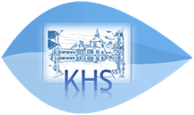

Policy updated: March 2022 Policy agreed by LAC: tbc 10.03.22
What we plant today, we grow tomorrow

