Kingswode Hoe School

SEN Policy

2022 - 2023

Kingswode Hoe School

Special Educational Needs Policy

In drawing up this Policy the school has considered the most recent SEN Code of Practice.

“Every learner is entitled to a curriculum rich and varied, challenging and inspiring, which enables every individual to fulfil her or his potential to the highest possible standard; so that all, for the benefit of all, are able to shape their destinies to create a better world... Every learner is entitled to benefit from access to a curriculum and a range of learning experiences of the highest standard possible, which take account of unequal starting points and which are provided irrespective of gender, ethnic background, age or disability.”

Introduction

Kingswode Hoe is a school catering for pupils with moderate, or complex learning difficulties (MLD). Many pupils may have additional difficulties such as ASD (Asperger); other syndromes; social,emotional and mental health needs; speech and language difficulties and other complex learning needs. All pupils have an Education Health Care Plan (EHCP) which is a condition of entry.

Staffing

There is no requirement for special schools to have a designated SENCO, but there are two teachers who have the accredited SENCO qualification.

All teachers employed at the school have skills and experience in teaching pupils with SEN.

The majority of support staff have experience and skills in supporting pupils with SEN either in special schools or in mainstream schools.

All staff are responsible for the progress of all pupils, irrespective of their SEN.

Curriculum

Our School Curriculum Plan is monitored regularly to ensure breadth, balance, continuity and progression through all Key Stages. The school curriculum model is based on 6 outcomes:

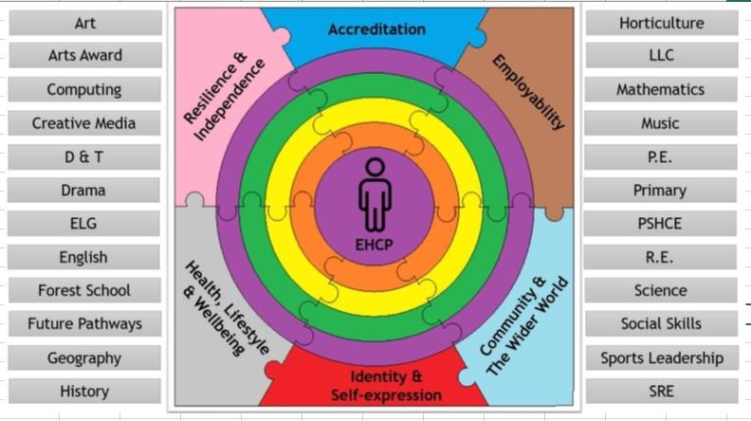
Pupils may be working from Programmmes of Study taken from a Key Stage below their chronological age.

Classes are grouped into Key Stages which will have a slightly different curriculum emphasis. KS2 concentrates on early literacy, numeracy and social skills. Most other subjects are taught through a thematic approach. They are taught by a specialist for PE, aspects of technology and for Forest School.

KS3 concentrates on literacy, numeracy, PSHE + citizenship and RSE as well as delivering the full range of subjects excluding a modern foreign language. Over Y7, 8 and 9, the range of specialist teaching increases. There are specialist interventions available such as speech and language groups, Read WriteInc Phonics, Numicon and Forest School.

KS4 concentrates on work related,careers and enterprise work as well as a wide variety of externally accredited courses including the Duke of Edinburgh Award. There are opportunities to take part in college link programmes, extended work placements and tailored work experience.

Our curriculum is designed to allow for varying paces of learning. All learning objectives are differentiated according to need and additional adult support is given wherever possible.

Each pupil has a Pupil Passport which gives details of their learning and medical needs, preferred learning style, and support needed as well as targets taken from their Education Health Care Plan (EHCP).
We also aim to raise pupils’ self-esteem and independence by providing them with opportunities for success in their learning and other areas of experience.

In order to meet the needs of the very wide range of pupils in KS3 and KS4 we have modified the curriculum for some pupils.

We recognise the need to support well-being for all pupils and have developed the GROW ethos which promotes the emotional wellbeing of our pupils.

Pupils

We are aware of the individual learning needs of all the pupils who attend the school as set out on their Education and Halth Care Plan. Progress towards these targets are assessed in the same way as progress in the curriculum through the Evidence app. Parents and carers have access to this information through the app.

Some of our pupils will have needs over and above those already described. Some will have medical difficulties (asthma, epilepsy, genetic disorders), others will have dyslexia, dyspraxia or severe speech delay or disorder. In addition, many pupils have difficulties which place them on the autistic spectrum, either with or without a formal diagnosis.

Any additional support given to these pupils will be outlined in their Pupil Passport and are likely to fall within the following areas.

Additional SEN | Additional Provision
1. Medical | Administration of medicines in school.  Specialist feeding tubes.  Epipen  Support from specialist health care practitioners as necessary.  Training for members of staff where appropriate on aspects of delivering healthcare. There is no school nurse. These pupils will all have an individual Healthcare Plan which is regularly reviewed.
2. Dyslexia – (SpLd) | Pupil Passports will give details of their literacy/numeracy programme. This may involve additional teaching sessions and curriculum or resource adaptations.  All teaching staff will be made aware  of their difficulties and the implications for their learning.

Additional SEN | Additional Provision
3. Dyspraxia and dysphagia | Pupils might have a physiotherapy programme and/or a speech and language programme delivered by support staff in school.  Designated support staff will support and monitor as required, working under instruction from health care professionals.  There is no school physiotherapist or occupational therapist. The speech and language therapist visits for half a day per week to monitor pupils on the case load and support school staff.
4. ASD + Asperger’s Syndrome | Their work will be supported using visual strategies such as visual timetables. In addition, individual strategies for sensory needs can be put in place as necessary. There is no sensory room in the school, but classrooms may have a dedicated sensory area.
5. Speech and Language needs -  (SCLD) | Pupils with a speech and language needs will have access to the Speech and Language Therapist either individually, in groups if that it written in the EHCP. There is a specialist HLTA for speech and language who can deliver an agreed programme or give more general support and advice to pupils with these needs. The school is allocated external Speech and Language provision once a fortnight and the Provide Therapist makes recommendations for staff in school to follow. The school does not employ its own Speech and Language Therapist.

Additional SEN | Additional Provision
6. Visual/ hearing Impairment –  (VI/ HI) | Advice and support from the  Specialist Teacher teams put in place  for individuals through Pupil Passports.  Designated BSL signers to provide informal support to HI pupils.  Adapted building to cater for specific needs in certain circumstances: such as visual fire alarms, low contrast screens and specialist IT programs.
7. Social, emotional and mental health needs | Many pupils have emotional difficulties and this may be reflected in challenging behaviour. Emotional or mental health issues may also be reflected in a variety of reactions such as depression, self harm or lack of self worth.  Responses will be on an individual basis and may include individual or group sessions with well-being staff, a behaviour programme, an individual support programme or individual therapies such as Art Therapy.  Staff may signpost additional or more intensive support available from specialists in emotional or mental health.  There is a senior member of staff responsible for pupil well-being.

Links with Parents and Carers

Parents and carers do not have the usual ‘mainstream’ opportunities to meet with each other, other pupils, teachers and other staff on a daily basis since by and large they do not accompany their children to and from the school. It is important for us to recognise this and we try to provide opportunities for parents to share the work of the school :
- by maintaining “Home/School” diaries on a daily basis
- by access to activities, targets and assessments via the E4L app
- by ensuring information is sent home via newsletters
- by arranging termly Open Evenings
- by encouraging parents to attend EHCP Reviews
- by encouraging parental contact with form tutors and pastoral leads

Locality Working

Kingswode Hoe aims to share our experience and expertise with schools in our locality and our consortia. This work also provides opportunities to extend the opportunities for our pupils to work in mainstream settings either for specific academic purposes or as part of our social inclusion work. Where we have pupils who demonstrate high levels of progress, reintegration into mainstream is encouraged and supported. We aim to provide curriculum support and advice to mainstream secondary and primary schools and their SENCOs.

Links with other agencies

The school has links with other agencies who may well be involved in supporting the pupil and their SEN. Other agencies include Educational Psychologists, Statutory Assessment Service, Social Care and Health Services.

Parental Complaints Relating to the Curriculum

These procedures are set out in the SEAX Trust complaints policy, available from the website.

Last Reviewed:

September 2022

