**Child Protection and Safeguarding Policy for Kingswode Hoe School**

*To be reviewed: September 2024 (or in line with statutory updates)*

|  |  |
| --- | --- |
| **DESIGNATED SAFEGUARDING LEAD TEAM LEADER** | Ben Lee |
| **DESIGNATED SAFEGUARDING LEAD** | Alice Constantine |
| **DEPUTY DESIGNATED SAFEGUARDING LEAD**  **CLA & Wellbeing Lead** | Sophie Burrows and Kim Stephen |
| **DESIGNATED SAFEGUARDING SEAX Director of Academy Improvement** | Kim McWilliam |

**Safeguarding is EVERYONE’S responsibility**

**ANYONE can make a referral: 0345 603 7627**

**What we plant today, we grow tomorrow**

|  |  |
| --- | --- |
|  | http://www.seaxtrust.com/assets/images/logo.png |

Safeguarding and promoting the welfare of children is everyone’s responsibility. Everyone who comes into contact with children and their families has a role to play. In order to fulfil this responsibility effectively, all practitioners should make sure their approach is child-centred. This means that they should consider, at all times, what is in the best interests of the child.

*(Keeping Children Safe in Education – DfE, September, 2023)*

# 1. INTRODUCTION

This Child Protection Policy is for all staff, parents, local authority committee, volunteers and the wider school community. It forms part of the safeguarding arrangements for our school. It should be read in conjunction with the following:

* Keeping Children Safe in Education (DfE, 2023)
* Policy on behaviour and attitudes
* Staff Code of Conduct Policy
* Attendance Policy
* Anti-Bullying Policy
* E-safety Policy
* The role of the designated safeguarding lead (Annex B of KCSiE 2023)

Safeguarding and promoting the welfare of children is defined in Keeping Children Safe in Education as:

* Protecting children from maltreatment
* Preventing impairment of children’s health or development
* Ensuring that children grow up in circumstances consistent with the provision of safe and effective care
* Taking action to enable all children to have the best outcomes.

# 2. STATUTORY FRAMEWORK

Section 175 of the Education Act 2002 places a statutory responsibility on the multi-academy trust to have policies and procedures in place that safeguard and promote the welfare of children who are pupils of the school.

The development of appropriate procedures and the monitoring of good practice in Essex are the responsibilities of the [**Essex Safeguarding Children Board**](http://www.escb.co.uk/Home.aspx) **(ESCB)**. In Essex, all professionals must work in accordance with the [**SET Procedures**](http://dnn.essex.gov.uk/Portals/67/Documents/Local%20Practices/SET%20Procedures%202015%20-%20Version%202%20August%202015.pdf) **(ESCB, 2019)**.

Our school works in accordance with the following legislation and guidance:

* Keeping Children Safe in Education (DfE, 2022)
* Working Together (DfE, 2018)
* Education Act (2002)
* Effective Support for Children and Families in Essex (ESCB)
* Counter-Terrorism and Security Act (HMG, 2015)
* Serious Crime Act 2015 (Home Office, 2015)
* Children and Social Work Act (2017)
* Children Missing Education - statutory guidance for local authorities (DfE, 2016)
* Sexual Offences Act (2003)
* Education (Pupil Registration) Regulations 2006
* Information sharing advice for safeguarding practitioners (HMG, 2018)
* Data Protection Act (2018)
* What to do if you're worried a child is being abused (HMG, 2015)
* Searching, screening and confiscation (DfE, 2018)
* Children Act (1989)
* Children Act (2004)
* Preventing and Tackling Bullying (DfE, 2017)
* Female Genital Mutilation Act 2003 (S. 74 - Serious Crime Act 2015)
* Sexual violence and sexual harassment between children in schools and colleges (DfE, 2021)
* Promoting positive emotional well-being and reducing the risk of suicide (ESCB, 2018)
* Preventing youth violence and gang involvement (Home Office, 2015)
* Criminal Exploitation of children and vulnerable adult - county lines guidance (Home Office, 2018)
* Teaching on-line safety in schools (DfE, 2019)
* Education Access Team CME / Home Education policy and practice (ECC, 2018)
* Understanding and Supporting Behaviour - good practice for schools (ECC, 2021)

# 3. SCHOOL POLICY

We recognise that for our pupils, high self-esteem, confidence, supportive friends and clear lines of communication with a trusted adult helps to prevent abuse.

Our school therefore aims to:

* Establish and maintain an environment where pupils feel safe and secure, are encouraged to talk and are listened to
* Ensure that pupils know that there are adults in the school who they can approach if they are worried or are in difficulty
* Ensure pupils receive the right help at the right time to address risks and prevent issues escalating
* Include in the curriculum activities and opportunities for PSHCE, which equip pupils with the skills they need to stay safe from abuse and to develop healthy and safe relationships
* Include in the curriculum material which will help pupils develop realistic attitudes to the responsibilities of adult life, particularly with regard to childcare and parenting skills (RSE)
* Protect children from harm and to ensure that they are taught in a way that is consistent with the law and our values and to promote respect for all others
* Make parents and carers aware of the school policies and practice for safeguarding and ensure that, wherever possible, every effort will be made to establish open and honest effective working relationships with parents and colleagues from partner agencies
* Facilitate understanding of wider issues within the context of learning about the values on which our society is founded and our system of democratic government

# 4. ROLES AND RESPONSIBILITIES

All adults working with, or on behalf of, children have a responsibility to protect them and to provide a safe environment in which they can learn and achieve their full potential. However, there are key people in schools and the local authority who have specific responsibilities under child protection procedures. The names of those in our school with these specific responsibilities (the designated safeguarding lead and deputy designated safeguarding lead) are shown on the cover sheet of this document.

## **Academy Committee (AC) and SEAX Board of Trustees**

The AC and Trustees ensure that the policies, procedures and training in our school are effective and comply with the law at all times. They ensure that all required policies relating to safeguarding are in place and that the child protection policy reflects statutory and local guidance and is reviewed at least annually.

The AC ensures there is a named designated safeguarding lead and deputy safeguarding lead in place.

The AC ensures the school contributes to inter-agency working, in line with statutory and local guidance. It ensures that information is shared and stored appropriately and in accordance with statutory requirements.

The AC ensures that all staff members undergo safeguarding and child protection training at induction and that it is then regularly updated. All staff members receive regular safeguarding and child protection updates, at least annually, to provide them with the relevant skills and knowledge to keep our children safe.

The AC ensures that children are taught how to keep themselves safe (including online) through teaching and learning opportunities as part of a broad and balanced curriculum. From September 2020, our school will work in accordance with new government regulations which make the subjects of Relationships Education (for primary age pupils) and Relationships and Sex Education (for secondary age pupils) mandatory.

The AC and school leadership team are responsible for ensuring the school follows recruitment procedures that help to deter, reject or identify people who might abuse children. It adheres to statutory responsibilities to check adults working with children and has recruitment and selection procedures in place (see the school’s ‘Safer Recruitment’ policy for further information). It ensures that volunteers are appropriately supervised in school.

## **The Designated Safeguarding Lead (and Deputies**)

The designated safeguarding lead in school takes lead responsibility for managing child protection referrals, safeguarding training and raising awareness of all child protection policies and procedures. They ensure that everyone in school (including temporary staff, volunteers and contractors) is aware of these procedures and that they are followed at all times. They act as a source of advice and support for other staff (on child protection matters) and ensure that timely referrals to Essex Children’s Social Care (Family Operations Hub) are made in accordance with current Southend, Essex and Thurrock (SET) procedures. They work with the local authority and other agencies as required.

If for any reason the designated safeguarding lead is unavailable, the deputy designated safeguarding lead will act in their absence*.*

## **The Headteacher**

The headteacher works in accordance with the requirements upon all school staff. In addition, she ensures that all safeguarding policies and procedures adopted by the AC are followed by all staff.

## **All school staff**

Everyone in our school has a responsibility to provide a safe learning environment in which our children can learn. All staff members are prepared to identify children who may benefit from early help and understand their role within this process. This includes identifying any emerging problems so appropriate support may be provided and liaising with the designated safeguarding lead to report any concerns. All staff members are aware of and follow school processes (as set out in this policy) and are aware of how to make a referral to Social Care if there is a need to do so. **If staff have any concerns about a child’s welfare, they must act on them immediately and speak with the designated safeguarding lead (or deputy) – they do not assume that others have taken action.**

# 5. TYPES OF ABUSE/SPECIFIC SAFEGUARDING ISSUES

Keeping Children Safe in Education (DfE, 2021) defines abuse as the maltreatment of a child.

*‘a form of maltreatment of a child. Somebody might abuse or neglect a child by inflicting harm or by failing to act to prevent harm. Children may be abused in a family or in an institutional or community setting by those known to them, or more rarely, by others. Abuse can take place wholly offline, or technology may be used to facilitate offline abuse. Children may be abused by an adult or adults, or by another child or children.’*

The four main types of abuse referred to in Keeping Children Safe in Education are:

* Physical
* Emotional
* Sexual
* Neglect

Our school is aware of the signs of abuse and neglect so we are able to identify children who may be in need of help or protection. All staff are aware of environmental factors which may impact on a child’s welfare and safety and understand safeguarding in the wider context (contextual safeguarding). Staff are aware of safeguarding issues that can put children at risk of harm and understand that behaviours linked to issues such as drug taking, alcohol abuse, deliberately missing education and sexting put children in danger.

## **Peer on peer abuse**

Our school may be the only stable, secure and safe element in the lives of children at risk of, or who have suffered harm.  Nevertheless, whilst at school, their behaviour may be challenging and defiant, or they may instead be withdrawn, or display abusive behaviours towards other children. Our school recognises that some children may abuse their peers and that this may happen in school, or outside of it. Any incidents of peer on peer abuse will be managed in the same way as any other child protection concern and will follow the same procedures. We will seek advice and support from other agencies as appropriate.

Our school recognises that, even though peer on peer abuse / harmful sexual abuse may not reported, it is likely that it is occurring and we are clear there is a zero tolerance to inappropriate or abusive behaviour. We understand the barriers which may prevent a child from reporting abuse and work actively to remove these.

Peer on peer abuse can manifest itself in many ways. This may include bullying (including cyber bullying), physical abuse, sexual violence / sexual harassment, ‘up-skirting’, ‘sexting’ or initiation / hazing type violence and rituals. We do not tolerate any harmful behaviour in school and will take swift action to intervene where this occurs, challenging inappropriate behaviours when they occur – we do not normalise abuse, nor allow a culture where it is tolerated.

We use lessons and assemblies to help children understand, in an age-appropriate way, what abuse is and we encourage them to tell a trusted adult if someone is behaving in a way that makes them feel uncomfortable. Our school understands the different gender issues that can be prevalent when dealing with peer on peer abuse. We will never make a child feel ashamed for reporting abuse, nor that they are creating a problem by doing so.

## **Serious violence**

All staff are aware of indicators which may signal that children are at risk from or involved with serious violent crime. These may include increased absence from school, a change in friendships or relationships with older individuals or groups, a significant decline in performance, signs of self-harm or a significant change in well-being, or signs of assault or unexplained injuries. Unexplained gifts or new possessions could also indicate that a child has been approached by, or is involved with, individuals associated with criminal networks or gangs.

## **Children with special educational needs and disabilities**

As a special school, our school clearly understands that children with special educational needs (SEN) and disabilities can face additional safeguarding challenges. Additional barriers can exist when recognising abuse and neglect in this group of children. This can include:

* assumptions that indicators of possible abuse such as behaviour, mood and injury relate to the child’s disability without further exploration
* children with SEN and disabilities can be disproportionally impacted by things like bullying without outwardly showing any signs
* communication barriers and difficulties in overcoming these barriers.

## **Children missing from education**

All children, regardless of their age, ability, aptitude and any special education needs they may have are entitled to a full-time education. Our school recognises that a child missing education is a potential indicator of abuse or neglect and will follow the school procedures for unauthorised absence and for children missing education in line with our Attendance Policy. Parents should always inform us of the reason for any absence. Where contact is not made, a referral may be made to another appropriate agency (Missing Education and Child Employment Service, Social Care or Police). Parents and carers are required to provide at least two emergency contact numbers in school, so we are able to communicate with someone if we need to.

Our school must inform the local authority of any pupil who fails to attend school regularly, or has been absent without school permission for a continuous period of 10 days or more.

## **Child Sexual Exploitation (CSE) and Child Criminal Exploitation (CCE)**

Both CCE and CSE are forms of abuse that occur where an individual or group takes advantage of an imbalance in power to coerce, manipulate or deceive a child into taking part in sexual or criminal activity, in exchange for something the victim needs or wants, and/or for the financial advantage or increased status of the perpetrator or facilitator and/or through violence or the threat of violence. CSE and CCE can affect children, both male and female and can include children who have been moved (commonly referred to as trafficking) for the purpose of exploitation.

Some specific forms of CCE can include children being forced or manipulated into transporting drugs or money through county lines, working in cannabis factories, shoplifting or pickpocketing. They can also be forced or manipulated into committing vehicle crime or threatening/committing serious violence to others.

Child Sexual Exploitation (CSE) is a form of child abuse, which can happen to boys and girls from any background or community. It may occur over time, or be a one-off occurrence. In Essex, the definition of Child Sexual Exploitation (CSE) from the Department of Education (DfE, 2017) has been adopted:

*"Child Sexual Exploitation is a form of child sexual abuse. It occurs when an individual or group takes advantage of an imbalance of power to coerce, manipulate or deceive a child or young person under the age of 18 into sexual activity (a) in exchange for something the victim needs or wants, and/or (b) for the financial advantage or increased status of the perpetrator or facilitator. The victim may have been sexually exploited even if the sexual activity appears consensual. Child sexual exploitation does not always involve physical contact; it can also occur through the use of technology".*

It is understood that a significant number of children who are victims of CSE go missing from home, care and education at some point. Our school is alert to the signs and indicators of a child becoming at risk of, or subject to, CSE and will take appropriate action to respond to any concerns. The designated safeguarding lead will lead on these issues and work with other agencies as appropriate. This [one page process map](https://www.escb.co.uk/media/2075/cse-1-pager-sept-2019.pdf) sets out arrangements for CSE in Essex.

Our school works with key partners locally to prevent and respond to child criminal exploitation.

We recognise that our children are growing up in an increasingly complex world, living their lives on and offline. This presents many positive and exciting opportunities, but we recognise it also presents challenges and risks. Any pupil can be vulnerable online, and their vulnerability can fluctuate depending on their age, developmental stage and personal circumstance. We want to equip our pupils with the knowledge needed to make the best use of the internet and technology in a safe, considered and respectful way, so they are able to reap the benefits of the online world.

**Online safety**

The range of online risks could be categorised as:

**content:** being exposed to illegal, inappropriate or harmful material; for example, pornography, fake news, suicide, racist or radical and extremist views;

**contact:** being subjected to harmful online interaction with other users; for example, peer to peer pressure, commercial advertising as well as adults posing as children or young adults with the intention to groom or exploit them for sexual, criminal, financial or other purposes;

**conduct:** personal online behaviour that increases the likelihood of, or causes, harm; for example, making, sending and receiving explicit images, or online bullying

**commerce:** risks such as online gambling, inappropriate advertising, phishing and / or financial scams

All staff in our school are aware of the risks to children online and we seek to help children keep themselves safe online in a range of ways.

## **Contextual safeguarding**

Safeguarding incidents and behaviours can be associated with factors outside our school. All staff are aware of contextual safeguarding and the fact they should consider whether wider environmental factors present in a child’s life are a threat to their safety and/or welfare. To this end, we will consider relevant information when assessing any risk to a child and share it with other agencies to support better understanding of a child and their family.

## **Domestic abuse**

Domestic abuse can take many forms, including psychological, physical, sexual, financial and emotional. Our school recognises that exposure to domestic abuse can have a very serious, long term emotional and psychological impact on children. We work with other key partners and will share relevant information where there are concerns that domestic abuse may be an issue for a child or family or be placing a child at risk of harm.

## **So-called ‘honour-based violence’ (including Female Genital Mutilation (FGM) and forced marriage**

FGM comprises all procedures involving partial or total removal of the external female genitalia or other injury to female genital organs. It is illegal in the UK and a form of child abuse.

As of October 2015, the Serious Crime Act 2015 (Home Office, 2015) introduced a duty on teachers (and other professionals) to notify the police of known cases of female genital mutilation where it appears to have been carried out on a girl under the age of 18. Our school will operate in accordance with the statutory requirements relating to this issue, and in line with existing local safeguarding procedures.

A forced marriage is one entered into without the full consent of one or both parties. It is where violence, threats or other forms of coercion is used and is a crime. Our staff understand how to report concerns where this may be an issue.

## **Prevention of radicalisation**

As of July 2015, the [**Counter-Terrorism and Security Act (HMG, 2015)**](http://www.legislation.gov.uk/ukpga/2015/6/contents) placed a new duty on schools and other education providers. Under section 26 of the Act, schools are required, in the exercise of their functions, to have ‘due regard to the need to prevent people from being drawn into terrorism’. This duty is known as the Prevent Duty.

It requires schools to:

* teach a broad and balanced curriculum which promotes spiritual, moral, cultural, mental and physical development of pupils and prepares them for the opportunities, responsibilities and experiences of life and must promote community cohesion
* be safe spaces in which children and young people can understand and discuss sensitive topics, including terrorism and the extremist ideas that are part of terrorist ideology, and learn how to challenge these ideas
* be mindful of their existing duties to forbid political indoctrination and secure a balanced presentation of political issues.

CHANNEL is a national programme which focuses on providing support at an early stage to people identified as vulnerable to being drawn into terrorism. Our school works in accordance with local procedures for PREVENT and with other agencies, sharing information and concerns as appropriate.

### 6. Procedures

Our school works with key local partners to promote the welfare of children and protect them from harm. This includes providing a co-ordinated offer of early help when additional needs of children are identified and contributing to inter-agency plans which provide additional support (through a ‘child in need’ or a ‘child protection’ plan).

All staff members have a duty to identify and respond to suspected or actual abuse or disclosures of abuse. Any member of staff, volunteer or visitor to the school who receives a disclosure or allegation of abuse, or suspects that abuse may have occurred **must** report it immediately to the designated safeguarding lead or, in their absence, the deputy designated safeguarding lead.

All action is taken in accordance with the following guidance;

* Essex Safeguarding Children Board guidelines, the SET
* Child Protection Procedures (ESCB, 2019)
* Essex Effective Support
* Keeping Children Safe in Education (DfE, 2021)
* Working Together to Safeguard Children (DfE, 2018)
* Effective Support for Children and Families in Essex (ESCB, 2017)
* PREVENT Duty - Counter-Terrorism and Security Act (HMG, 2015)

Any staff member or visitor to the school must refer concerns to the designated safeguarding lead or deputy designated safeguarding leads. Where there is a risk of immediate harm, concerns will be referred by telephone to the Children and Families Hub and/or the Police. Less urgent concerns or requests for support will be sent to the Children and Families Hub via the **Essex Effective Support** portal. The school may also seek advice from Social Care or another appropriate agency about a concern, if we are unsure how to respond to it. Wherever possible, we will share any safeguarding concerns, or an intention to refer a child to Children’s Social Care with parents or carers. However, we will not do so where it is felt that to do so could place the child at greater risk of harm or impede a criminal investigation.

On occasions, it may be necessary to seek advice from the Children and Families Hub and/or Essex Police in making decisions about when it is appropriate to share information with parents or carers.

If a member of staff continues to have concerns about a child and feels the situation is not being addressed or does not appear to be improving, the staff member concerned should press for re-consideration of the case with the designated safeguarding lead.

If, for any reason, the designated safeguarding lead (or deputies) are not available, this should not delay appropriate action being taken. Safeguarding contact details are displayed in the school to ensure that all staff members have unfettered access to safeguarding support, should it be required. Any individual may refer to Social Care where there is suspected or actual risk of harm to a child.

When new staff, volunteers or regular visitors join our school they are informed of the safeguarding arrangements in place, the name of the designated safeguarding lead (and deputies) and how to share concerns with them.

### 7. Training

The designated safeguarding lead (and deputies) undertake Level 3 child protection training at least every two years. The headteacher and all staff members and AC members receive appropriate child protection training which is regularly updated and in line with advice from the Essex Safeguarding Children Board (ESCB). In addition, all staff members receive safeguarding and child protection training annually and updates as required, to provide them with relevant skills and knowledge to safeguard children effectively. Records of any child protection training undertaken is kept for all staff and the governing body.

The school ensures that the designated safeguarding lead (and deputies) also undertake training in inter-agency working and other matters as appropriate.

### 8. Professional confidentiality

Confidentiality is an issue which needs to be discussed and fully understood by all those working with children, particularly in the context of child protection. A member of staff must never guarantee confidentiality to a pupil and will not agree with a pupil to keep a secret as, where there is a child protection concern, this must be reported to the designated safeguarding lead and may require further investigation by appropriate authorities.

All staff members are informed of relevant information in respect of individual cases regarding child protection on a ‘need to know basis’ only. Any information shared with a member of staff in this way is treated confidentially.

### 9. Records and information sharing

Where there are concerns about the safety of a child, the sharing of information in a timely and effective manner between organisations can reduce the risk of harm. Whilst the Data Protection Act 2018 places duties on organisations and individuals to process personal information fairly and lawfully, it is not a barrier to sharing information where the failure to do so would result in a child or vulnerable adult being placed at risk of harm. Similarly, human rights concerns, such as respecting the right to a private and family life would not prevent sharing where there are real safeguarding concerns. Fears about sharing information cannot be allowed to stand in the way of the need to safeguard and promote the welfare of children at risk of abuse or neglect.

Well-kept records are essential to good child protection practice. Our school is clear about the need to record any concern held about a child or children in our school, the status of such records and when these records should be shared with other agencies.

Any member of staff receiving a disclosure of abuse or noticing signs or indicators of abuse, will record it as soon as possible, noting what was said or seen (if appropriate using a body map to record), giving the date, time and location. All safeguarding concerns are recorded electronically using My Concern secure system. This is then alerted to the designated safeguarding lead (or deputies), who will decide on appropriate action and record this accordingly.

If there are immediate concerns for a child’s safety, staff should report verbally to the designated safeguarding lead who will then begin necessary actions and make arrangements for the staff to have the time to write up the concern.

Any records related to child protection are kept in an individual child protection file for that child (which is separate to the pupil file). All child protection records are stored securely and confidentially and will be retained for 25 years after the pupil’s date of birth, or until they transfer to another school or educational setting.

In line with statutory guidance, where a pupil transfers from our school to another school or educational setting (including colleges), their child protection records will be forwarded to the new educational setting once we have confirmation that they are on roll. These will be marked ‘Confidential’ and sent by recorded/signed for delivery for the attention of the receiving school’s designated safeguarding lead, with a return address on the envelope so it can be returned to us in the event of non-delivery. We will obtain evidence that the paperwork has been received by the new school. Where appropriate, the designated safeguarding lead may also make contact with the new educational setting in advance of the child’s move there, to enable planning so appropriate support is in place when the child arrives.

Where a pupil joins our school, we will request child protection records from the previous educational establishment (if none are received).

### 10. Interagency working

It is the responsibility of the designated safeguarding lead to ensure that the school is represented at, and that a report is submitted to, any child protection conference called for children on the school roll or previously known to them. Where possible and appropriate, any report will be shared in advance with the parents or carers. The member of staff attending the meeting will be fully briefed on any issues or concerns the school has and be prepared to contribute to the discussions at the conference.

If a child is subject to a Child Protection or a Child in Need plan, the designated safeguarding lead will ensure the child is monitored regarding their school attendance, emotional well-being, academic progress, welfare and presentation. If the school is part of the core group, the designated safeguarding lead will ensure the school is represented, provides appropriate information and contributes to the plan at these meetings. Any concerns about the Child Protection plan and/or the child’s welfare will be discussed and recorded at the core group meeting, unless to do so would place the child at further risk of significant harm. In this case the designated safeguarding lead will inform the child’s key worker immediately and then record that they have done so and the actions agreed.

### 11. Allegations about members of the workforce

All staff members are made aware of the boundaries of appropriate behaviour and conduct. These matters form part of staff induction and are outlined in the Staff Handbook and Staff Code of Conduct.

The school works in accordance with statutory guidance and the SET procedures (ESCB, 2019) in respect of allegations against an adult working with children (in a paid or voluntary capacity). Section 7 of the current SET procedures provides detailed information on this.

The school has processes in place for reporting any concerns about a member of staff (or any adult working with children). Any concerns about the conduct of a member of staff will be referred to the headteacher. This role is distinct from the designated safeguarding lead as the named person should have sufficient status and authority in the school to manage employment procedures. Staffing matters are confidential and the school must operate within statutory guidance around Data Protection.

Where the concern involves the headteacher, it should be reported direct to AC member Sandra Page or the AC Chair and SEAX Trustee who will liaise with SEAX HR as appropriate.

SET procedures (ESCB, 2019) require that, where an allegation against a member of staff is received, the headteacher, senior named person or Chair of Academy Committee must inform the duty Local Authority Designated Officer (LADO) in the Children’s Workforce Allegations Management Team on **03330 139 797** within one working day. However, wherever possible, contact with the LADO should be made immediately as they will then advise on how to proceed and whether the matter requires police involvement. This will include advice on speaking to pupils, parents and HR. The school does not carry out any investigation before speaking to the LADO.

### 12. Promoting positive mental health and resilience in school

Positive mental health is the concern of the whole school community and we recognise that schools play a key part in this. Our school aims to develop the emotional wellbeing and resilience of all pupils and staff. We understand that there are risk factors which increase someone’s vulnerability and protective factors that can promote or strengthen resilience. The more risk factors present in an individual’s life, the more protective factors or supportive interventions are required to counter-balance and promote further growth. It is vital that we work in partnership with parents to support the wellbeing of our pupils. Parents should share any concerns about the wellbeing of their child with the school, so appropriate support and interventions can be identified and implemented. Staff at Kingswode Hoe School are trained in ESSEX STEPS, they use strategies to de-escalate situations and also to guide children in safe ways to prevent harm to themselves or others. Training is refreshed regularly and we are fortunate that our KS2 and CLA Lead, Helen Davey, is a nationally Accredited Trainer.

Records are kept of any physical interventions required.

*(Refer to our policy for behaviour and attitudes)*

### 14. Whistleblowing

All members of staff and the wider school community should be able to raise concerns about poor or unsafe practice and feel confident any concern will be taken seriously by the school leadership team. We have ‘whistleblowing’ procedures in place and these are available in the school Whistleblowing Policy. However, for any member of staff who feels unable to raise concerns internally, or where they believe their concerns have not been addressed, they may contact the NSPCC whistleblowing helpline on: 0800 028 0285 (line is available from 8.00am to 8.00pm, Monday to Friday) or by email at: help@nspcc.org.uk

Parents, carers or others in the wider school community with concerns can contact NSPCC general helpline on: 0808 800 5000 (24-hour helpline) or email: help@nspcc.org.uk

# Appendix A: Children and Families Hub flow chart

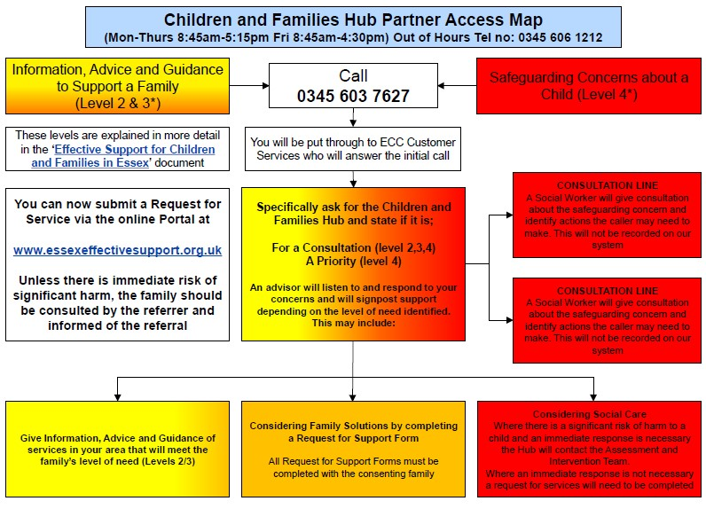

# Appendix B: Essex Windscreen of Need and Levels of Intervention

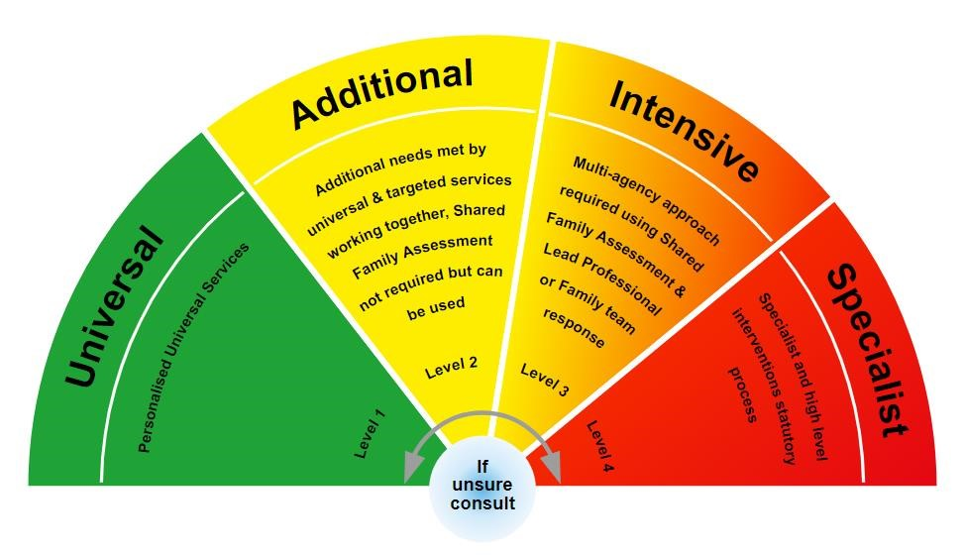

All partners working with children, young people and their families will offer support as soon as we are aware of any additional needs. We will always seek to work together to provide support to children, young people and their families at the lowest level possible in accordance with their needs.

Children with **additional** needs are best supported by those who already work with them, such as Family Hubs or schools, organising additional support with local partners as needed. When an agency is supporting these children, an Early Help Plan and a Lead Professional are helpful to share information and co-ordinate work alongside the child and family.

For children whose needs are **Intensive**, a coordinated multi-disciplinary approach is usually best, involving either an Early Help Plan or a Shared Family Assessment (SFA), with a Lead Professional to work closely with the child and family to ensure they receive all the support they require. Examples of intensive services are children’s mental health services and Family Solutions.

**Specialist** services are where the needs of the child are so great that statutory and/or specialist intervention is required to keep them safe or to ensure their continued development. Examples of specialist services are Children’s Social Care or Youth Offending Service. By working together effectively with children that have additional needs and by providing coordinated multi-disciplinary and agency support and services for those with intensive needs, we seek to prevent more children and young people requiring statutory interventions and reactive specialist services.

# Appendix C: Process for CSE arrangements in Essex

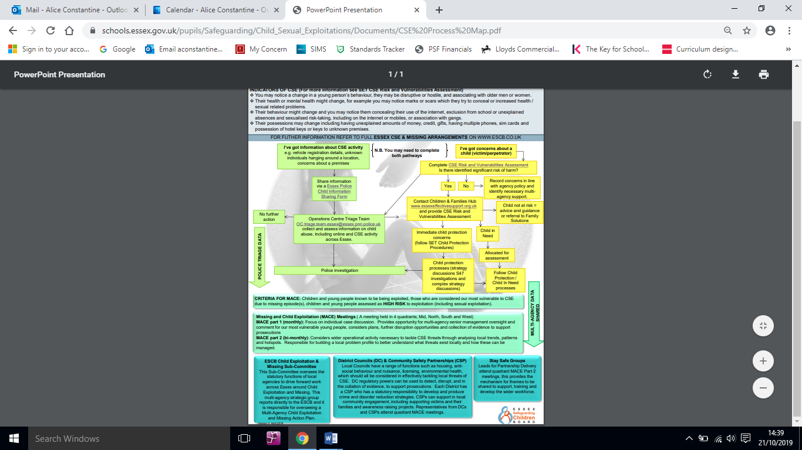

**Appendix D – Harmful Sexual Behaviour / Peer on Peer Abuse**

**1. Introduction**

It is normal for some children and young people (CYP) to display sexualised behaviour towards their peers as they develop. However, sexualised behaviour between peers that has become harmful or abusive is unacceptable and must be addressed.

Our school recognises that CYP are vulnerable to and capable of abusing their peers sexually. We consider any allegation of peer on peer sexual abuse seriously and do not tolerate or pass off harmful sexual behaviour as ‘banter’, ‘just having a laugh’ or ‘part of growing up’. These allegations are managed in the same way as any other child protection concern and follow the same procedures, including seeking advice and support from other agencies as appropriate.

This policy is in line with the safeguarding requirements in [Keeping Children Safe in Education](https://eur02.safelinks.protection.outlook.com/?url=https%3A%2F%2Fassets.publishing.service.gov.uk%2Fgovernment%2Fuploads%2Fsystem%2Fuploads%2Fattachment_data%2Ffile%2F954314%2FKeeping_children_safe_in_education_2020_-_Update_-_January_2021.pdf&data=04%7C01%7C%7Cf2e9fff87b2149eb72d208d8fe84ac80%7Ca8b4324f155c4215a0f17ed8cc9a992f%7C0%7C0%7C637539193225028841%7CUnknown%7CTWFpbGZsb3d8eyJWIjoiMC4wLjAwMDAiLCJQIjoiV2luMzIiLCJBTiI6Ik1haWwiLCJXVCI6Mn0%3D%7C1000&sdata=VnfJGiVrh%2BweNNu%2BiwjdcWv8RJzWF6EvSn1d8NGC7oE%3D&reserved=0) (Department for Education (‘DfE’), 2021), which we must work to; Part 5 of the Keeping Children Safe in Education statutory guidance sets out how schools should manage reports of child-on-child sexual violence and harassment. This policy also links to the guidance issued by the DfE in 2021: [Sexual violence and sexual harassment between children in schools and colleges](https://eur02.safelinks.protection.outlook.com/?url=https%3A%2F%2Fwww.gov.uk%2Fgovernment%2Fpublications%2Fsexual-violence-and-sexual-harassment-between-children-in-schools-and-colleges&data=04%7C01%7C%7Cf2e9fff87b2149eb72d208d8fe84ac80%7Ca8b4324f155c4215a0f17ed8cc9a992f%7C0%7C0%7C637539193225038798%7CUnknown%7CTWFpbGZsb3d8eyJWIjoiMC4wLjAwMDAiLCJQIjoiV2luMzIiLCJBTiI6Ik1haWwiLCJXVCI6Mn0%3D%7C1000&sdata=ZYrHV9%2FJUndIMjNVX505sSFT9UICMSs637uOd9Oag4Q%3D&reserved=0).

**2. Definition of sexual abuse**

Forcing or enticing a child or young person to take part in sexual activities, not necessarily involving a high level of violence, whether or not the child is aware of what is happening. The activities may involve physical contact, including assault by penetration (for example rape or oral sex) or non-penetrative acts such as masturbation, kissing, rubbing and touching outside of clothing. They may also include non-contact activities, such as involving children in looking at, or in the production of, sexual images, watching sexual activities, encouraging children to behave in sexually inappropriate ways, or grooming a child in preparation for abuse. Sexual abuse can take place online, and technology can be used to facilitate offline abuse.

The sexual abuse of children by other children is a specific safeguarding issue in education.

*(Keeping children safe in education, DfE, 2021)*

**3. Harmful sexual behaviour**

Harmful sexual behaviour can manifest itself in many ways. This may include:

* inappropriate or unwanted sexualised touching;
* sexual violence and sexual harassment;
* upskirting, which typically involves taking a picture under a person’s clothing without them knowing, with the intention of viewing their genitals or buttocks to obtain sexual gratification, or cause the victim humiliation, distress, or alarm;
* pressurising, forcing, or coercing someone to share nude images (known as sexting or youth produced sexual imagery);
* sharing sexual images of a person without their consent;
* bullying of a sexual nature online or offline, for example sexual or sexist name-calling.

Our school also understands the different gender issues that can be prevalent when dealing with harmful sexual behaviour.

CYP can experience harmful sexual behaviour in various settings. This includes at school, at home (or at another home), in public places, and online. At school, issues can occur in places which are supervised and unsupervised. For example, abuse may occur in toilets, corridors, classrooms, changing areas, outside spaces such as the playground and sports facilities and when CYP are travelling home (including on transport).

**4. How we seek to minimise the risk of harmful sexual behaviour**

The principle aim of our approach is to foster the conditions in which our pupils can aspire to and realise safe and healthy relationships, at school and as they continue in life. We work to a culture in which the voice of our CYP is central, where pupils feel able to share their concerns openly, knowing that they will be listened to, and that they will not be judged.

**Children and young people**

We use PSHE and relationships, sex and health education (RSE and Health Education curriculum) to help our pupils understand, in an age-appropriate way, what harmful sexual behaviour is, including by peers. We teach them the knowledge they need to recognise and report abuse, including emotional, physical, and sexual abuse. We also teach them about the importance of making sensible decisions to stay safe (including online), whilst being clear that if a CYP is abused, it is never their fault.

We help our pupils to develop the skills to understand:

* what constitutes harmful sexual behaviour;
* that such behaviour is not acceptable;
* the possible reasons for such behaviour, and vulnerability of perpetrators;
* that they must tell a trusted adult if someone is behaving in a way that makes them feel uncomfortable – and must tell a trusted adult if they witness such behaviour towards others.

We understand our pupils may not always feel able to talk to adults about peer-on-peer sexual abuse. To help them, we will encourage them to share their thoughts and opinions, respond to their concerns, and respect and listen to them. We want our pupils to feel confident that any concerns they raise will be responded to appropriately.

**Parents and carers**

It is important that parents and carers understand what is meant by harmful sexual behaviour and reinforce key messages from school at home. We work in partnership with parents to support our pupils and want to help them keep their child/ren safe. Parents and carers should understand:

* the nature of harmful sexual behaviour;
* the effects of harmful sexual behaviour on CYP;
* the likely indicators that such behaviour may be taking place;
* what to do if it is suspected that peer on peer sexual abuse has occurred;

Further information to support parents and carers in relation to harmful sexual behaviour is available online, including on the [NSPCC](https://www.nspcc.org.uk/what-is-child-abuse/types-of-abuse/child-sexual-abuse/#support) and [Lucy Faithfull Foundation](https://www.lucyfaithfull.org.uk/parents-protect.htm) websites.

**Staff**

Our staff undertake annual safeguarding training where the different types of abuse and neglect are discussed; this includes information about harmful sexual behaviour and our expectations for staff vigilance about this and other potential types of abuse. Staff also receive updates on safeguarding issues throughout the school year, including about the nature and prevalence of harmful sexual behaviour, where appropriate.

Importantly, the training also ensures that our staff know what to do if they receive a report that harmful sexual behaviour may have occurred, including how to support CYP.

**5. Our response to an incident / allegation**

The wellbeing of our pupils is always central to our response to an allegation or incident of harmful sexual behaviour. Any CYP reporting a concern will be treated respectfully. We will reassure them that they are being taken seriously and that they will be supported and kept safe; no CYP will be given the impression that they are creating a problem by reporting abuse or made to feel ashamed.

Our staff will never promise confidentiality to the CYP as the concern will need to be shared further. The school’s Designated Safeguarding Lead will need to be informed as soon as possible of any incident and the details may also need to be shared with Children’s Social Care / the police and other specialist agencies. We have in place effective working relationships with our safeguarding partners, which are essential to ensuring that concerns are appropriately managed.

We will explain next steps to the CYP at an appropriate language, social and developmental level so they understand what will happen, including who will be informed. Where the CYP already has Social Care involvement, such as a Looked After Child, a Child In Need or a child with a Child Protection Plan, we will inform the child’s Social Worker and work in partnership with them as appropriate.

Whilst we establish the facts of the case and start the process of liaising with other agencies as appropriate, we will consider how best to keep the victim and alleged perpetrator a reasonable distance apart on school premises, and where applicable, on transport to and from the school.

Where an incident includes an online element, we will always work in accordance with appropriate guidance, taking advice from other partners as necessary. Our staff will not view an indecent image of a CYP, nor forward it for any reason.

**Recording**

It is essential that information relating to allegations about harmful sexual behaviour are recorded within our school, as with any other child protection concern – and in line with our Child Protection Policy. The record may form part of a statutory assessment by Children’s Social Care or by another agency.

Any member of staff receiving a disclosure of harmful sexual behaviour or noticing signs or indicators of this, will record it as soon as possible on My Concern, noting what was said or seen giving the date, time and location. The facts will be recorded as the CYP presents them.

The record will then be presented to the Designated Safeguarding Lead (or Deputy), who will decide on appropriate action and record this accordingly.

If a CYP is at immediate risk of harm, staff will speak with the Designated Safeguarding Lead or Deputy first, and deal with recording as soon as possible afterwards.

All related concerns, discussions, decisions, and reasons for decisions will be dated and signed and will include the action taken.

**Investigation**

The Designated Safeguarding Lead will be responsible for leading investigations, and for liaising with other agencies as appropriate, for example Children’s Social Care and the police. They will also be the main point of contact for parents and carers. The Designated Lead will ensure there are accurate records of each stage of the investigation and that any supporting information is included in the Child Protection files.

**Risk Assessment**

Where appropriate, we will complete a risk assessment following a report of harmful sexual behaviour, considering all CYP involved in an incident. We will also consider all other pupils at our school and any actions that may be appropriate to protect them.

Risk assessments will be regularly reviewed to ensure they remain relevant and fit for purpose. Where appropriate, the affected CYP and their parents and carers will be invited to contribute to the completion and review of the risk assessment.

**6. Guiding principles**

The safety of our pupils is paramount. We will use a proportionate approach, basing our actions on the principle that harmful sexual behaviour is not acceptable and will not be tolerated.

All concerns will be considered carefully and on a case by case basis, underpinned by robust risk assessments. Our actions will not be judgemental about the guilt of the alleged perpetrator and will always be taken in the interests of all CYP concerned.

Our approach will help us to ensure that all pupils are protected and supported appropriately. The following principles will guide us:

* the wishes of the CYP in terms of how they want to proceed – the victim and their family will be given as much control as is reasonably possible over decisions regarding how any investigation will be progressed and any support that they will be offered;
* the nature of the alleged incident(s), including whether a crime may have been committed;
* the ages and developmental stages of all CYP involved;
* consideration of any power imbalance between the CYP (eg based on age, needs, confidence, stages of development).
* consideration of whether the alleged incident is a one-off or a sustained pattern of abuse;
* consideration of any ongoing risks to the victim, other CYP, or staff;
* consideration of any other related issues and wider context.

**Supporting the CYP who has allegedly experienced harmful sexual behaviour**

We will assess what short-term and long-term support a CYP may need to help them manage the immediate aftermath of an incident, and to recover from what they have experienced. The CYP’s existing support network will be central to this work; we will work with other partners as appropriate and in accordance with the CYP and family’s wishes.

We will consider what is necessary to support the CYP straightaway, for example by making adaptations to their timetable and in-school support and taking steps to protect them from attention or peer pressure they may experience due to making a report. This work will be guided by a robust risk assessment process and we will ensure that the CYP and their parents / carers have an opportunity to contribute. We will also ensure there is regular review of arrangements to be confident they meet the needs of all involved.

It may be necessary to make requests for support to mental health and wellbeing services or for therapeutic intervention. We may also need to link with other agencies to remove inappropriate material from the Internet, such as the [Internet Watch Foundation](https://www.iwf.org.uk/).

**Supporting the CYP who has allegedly displayed harmful sexual behaviour**

We have a duty of care to all pupils and we will protect and support CYP who have displayed abusive or harmful sexual behaviour. We will do this through considering the needs of the CYP, any risks to their safety and what multi-agency responses are needed to support them and their family. This work will be guided by a robust risk assessment process and we will ensure that the CYP and their parents / carers have an opportunity to contribute. We will also ensure there is regular review of arrangements to be confident they meet the needs of all involved.

Some CYP may not realise they have behaved abusively. We will avoid using language that may make them feel judged or criminalised and ensure that any intervention will be at the least intrusive level required to effectively address the behaviour.

We will consider appropriate sanctions using our behaviour policy, and work with the CYP and their support network to consider measures that may help to address the CYP’s behaviour.

**7. Investigation outcomes**

Our investigation of an allegation or incident as set out in this policy will enable us to determine the outcome, working with our safeguarding partners as appropriate. We will always seek to ensure that the outcome of an investigation is appropriate and proportionate to the circumstances in relation to the report. Various options are open to us, as set out below:

**Manage internally**

In some cases, for example, one-off incidents, we may take the view that the CYP concerned are not in need of early help or statutory intervention. In these cases, we will follow our other school policies in addressing matters, for example our behaviour / anti-bullying policies, and will communicate with the appropriate parents and carers about the incident and how we are responding.

We will also consider what support the CYP involved may need going forward. We will also consider whether any intervention or support is required as part of a whole setting approach or with the wider school community.

**Early Help**

Where statutory intervention is not required or agreed, we may use early help instead. This means providing support as soon as a problem emerges, at any point in a CYP’s life. We will work with parents and carers and other relevant partners when following this approach, which can be particularly useful in addressing non-violent harmful sexual behaviour and may prevent escalation.

**Requests for support to Children’s Social Care**

Where a CYP has been harmed, is at risk of harm, or is in immediate danger, we will make a request for support to Children’s Social Care. We will inform parents and carers of this unless to do so may put a CYP at additional risk. We will seek advice from other partners on such matters.

If we make a request for support, Children’s Social Care will consider whether the CYP involved are in need of protection or other services. Where statutory assessments are appropriate, the school will work with Children’s Social Care and other agencies as appropriate. Partnership working helps to ensure the best possible package of coordinated support is implemented for the

victim and, where appropriate, the alleged perpetrator and any other CYP that requires support.

In some cases, Children’s Social Care will review the evidence and decide a statutory intervention is not appropriate. If a statutory assessment is not considered appropriate by Children’s Social Care, we will consider what other support may be required. We will make further requests for support to Children’s Social Care if we consider that a CYP remains in immediate danger or at risk of harm.

**Reporting to the police**

Where a report of rape, assault by penetration or sexual assault is made, we will report it to the police. We will generally inform parents or carers about reports of sexual abuse, unless to do so may put a CYP at additional risk. We will seek advice from other partners in individual cases.

In circumstances where parents or carers have not been informed, we will ensure that we support the CYP in any decision we take. This is likely to be with the support of Children’s Social Care and any appropriate specialist agencies.

Where we have made a report to the police, we will consult with them and agree what information can be disclosed to staff and others, in particular the alleged perpetrator and their parents or carers. We will also discuss the best way to protect the victim and their anonymity.

Where there is a criminal investigation, we will work closely with the police and other agencies as appropriate to support all CYP involved (including potential witnesses). This will help to ensure that any actions we take do not jeopardise a police investigation. Sometimes the police will decide that further action is not required. In these circumstances we will continue to engage with other agencies to support the CYP involved.

**8. Review**

All child protection concerns are reviewed regularly, to ensure that everything has been fully addressed, that actions are completed, and to consider whether the CYP involved need any further support. We will continue to work with parents and carers and other agencies as appropriate, and risk assessments will be reviewed and updated as required.